**Presentation Notes:**

1. What are the four functions of a computer program listed on the lesson slide?
   1. Word VS. PowerPoint
   2. Word vs. Photoshop
   3. Word vs. Computer Games
   4. Word vs. Imovie
2. Provide an example of a computer input that is not listed on the lesson slide.

One example would be a TV remote as the buttons you press affect the TV screen

1. Provide an example of a computer output that is not listed on the lesson slide.

One example of an output device would be the movements of a robot

1. Provide another example of how a computer input affects a computer output that is not listed on the lesson slide.

If you press the power button on the monitor, the monitor either switches off or on

1. Provide an example of how changing the program changes how computer inputs affect computer outputs that is not listed on the lesson slide.

Word Vs. iMovie, as they keys on the keyboard have different functions as the application is open

1. What are some examples of devices that are not traditional computers but that make use of computer programs?
   1. Industrial Robots
   2. Cars which are not self-driving
   3. Kitchen Appliances
   4. Internet/social media bots
   5. Toy cars
2. Provide another example of a device that makes use of a computer program that is not listed on the lesson slide.

In the federal elections parties such as the liberal party use computer program to post their campaign videos as time goes.

1. What is another term for a computer program?

Computer program is also known as computer software

1. What are some ways that computer software is different from computer hardware?

* Software uses logic which is flexible and easily changed
* Hardware uses physical devices which are hard to change

1. How are computer programs written?

* Computer programs are written in plain text
* The programs are created using a keyboard and editor
* Computer programs are stored in a file which can be loaded and executed by a computer
* Computer programs can be written in many different computer languages

1. Why are computer programs composed of many lines of computer code?

* Each line of code represents a simple command or statement
* A complex code is made of a dozen or many logical program statements or many lines of code
* A complete computer program can be made of thousands of line of computer code

1. List some examples of different computer languages.
   1. C/C+ which is used for engineering
   2. Java which is used for web application development
   3. COBOL/SQL which is used for business
   4. Python which is used for simpler codes
2. List some of the benefits of the Python computer language.
   1. It is a professional language with a large user base
   2. Is good for prototyping or in other words testing smaller programs
   3. Is a good beginner language
   4. It is the language of choice for first year uni students
3. Once you finish this course, how could you answer someone who asks you "Do you know how to program in Java?"

Yes, I know how to program simple codes as if you know 1 type of code it is easy to learn others

1. Could you use Microsoft Word to write a computer program? Explain.

Yes but it lacks support to make programming easier

1. What does IDE stand for?

IDE stands for integrated development environemt

What it does: provides extra supports and tools designed specifically for creating and maintaining computer programs

1. What are some features of an Integrated Development Environment?
   1. Colour coding of keywords
   2. Indentation and completion control
   3. Error checking
   4. Runtime support and debugging
   5. Find problems right when writing code
2. What are some factors to consider when choosing an Integrated Development Environment?
   1. How well does it support your chosen language
   2. Is it web based or a download install
   3. Does it cost money
3. What is the name of the IDE that we will be using to create our Python programs?

* IDE we will be using is Repl.it
* Supports many different programming languages

1. What version of Python will we be using?

Python 3.7 (do not use python 2.7)

1. Draw a sketch of the Repl interface showing the three work areas (panels)
   1. Label each panel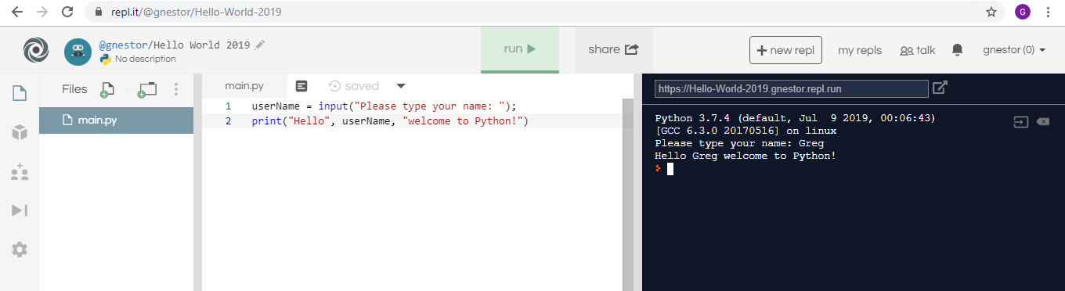

Black area for simple commands

This area for longer commands

* 1. Summarize the function of each panel

Use white area for longer programs

Use black area for simple commands

Buttons at the top to run your program

**Student Questions:**

1. Create an account for yourself at www.repl.it
   1. Review the "Terms of Service" to verify that you can legally use this service.
   2. Follow the previous discussed guidelines regarding use of personal information
2. List the part of the "Terms of Service" that verifies that you can legally use this service.

Your access to and use of the Service is conditioned upon your acceptance of and compliance with these Terms. These Terms apply to all visitors, users and others who wish to access or use the Service. By accessing or using the Service you agree to be bound by these Terms. If you disagree with any part of the terms, then you do not have permission to access the Service.

1. Explain some of the rights that you give away to Repl.it regarding content you create using their service?

we cannot use the service for The sale of access to the Service;

The sale of advertising, sponsorships, or promotions placed on or within the Service or Neoreason’s content; or

The sale or advertising, sponsorships, or promotions on any page of an ad-enabled blog or website containing content delivered via the Service, unless other material not obtained from Neoreason appears on the same page and is of sufficient value to be the basis of such sales.

1. Create a new Python repl and call it "Hello World".
2. Copy and paste the following program into the program panel (white area)

userName = input("Please type your name: ");

print("Hello", userName, "welcome to Python!")

1. Run the program to see what it does. (If necessary, fix the quotation marks so it runs properly.)
   1. Explain how the program works.
   2. Explain how you fixed the program (if necessary)
2. Try using the console pane (black area) to perform some simple calculations and run some one-line programs.
   1. Summarize some of your calculations.
3. Try using the file management pane to add some files and folders to your repl.
   1. Summarize some of your additions.